| **Name : Yash Sarang** | **Class/Roll No. : 47** | **Grade :** |
| --- | --- | --- |

**Title of Experiment :** Project Proposal and Requirement Gathering (Choose the project). Briefly state the problem(s) that the project will seek to solve. Take the user's point of view. Consider what the user's goals are, and what obstacles lie in the way.

**Objective of Experiment :** To perform user analysis, task analysis and domain analysis for an application.

**Outcome of Experiment :** We did user analysis, task analysis and domain analysis for a cab booking application and designed a user persona and entity relationship diagram for it.

**Problem Statement :** To study a cab booking application properly. Then perform user analysis, training analysis and domain analysis on the application to identify the issues and improvement that are needed by the user. To develop a user persona and entity relationship diagram for same.

**Description / Theory :**

**UI / UX:**

UI (User Interface) is about how a digital product looks and feels. It includes buttons, menus, and visuals users interact with directly.

UX (User Experience) is about the overall experience users have with a product.

It’s about making sure the product is easy to use, useful, and enjoyable. Good UX keeps users happy and engaged.

**User Analysis:**

User analysis UI / UX (User Interface / User Experience) refers to the process of studying and understanding the behaviors, preferences, needs, and characteristics of the target users of a digital product or service. It involves gathering and analyzing data to gain insights into how users interact with the interface, what challenges they face, and how their experiences can be improved.

**User Persona:**

In the context of UI / UX design, a user persona is a fictional representation of a target user group that helps designers and developers better understand and empathize with their intended audience. User personas are created through research and analysis of real user data to capture the characteristics, behaviors, goals, needs, and preferences of different types of users who might interact with a product, website, app, or service.

## **User Analysis:**

### Target Users:

* Patients: Individuals seeking to purchase prescription or over-the-counter medications online.
* Doctors: Medical professionals prescribing medications to their patients.
* Pharmacists: Professionals managing medication dispensing and providing information.

## **Task Analysis:**

### 1. Patient Registration and Ordering:

* Subtasks:
  + Create an account with personal and medical information.
  + Browse and search for medications.
  + Add medications to the cart.
  + Proceed to checkout and place an order.
  + Provide payment and shipping details.

### 2. Doctor Prescription Verification:

* Subtasks:
  + Access the system with a secure login.
  + Review and verify prescriptions uploaded by patients.
  + Confirm the accuracy and appropriateness of the prescribed medication.
  + Approve or reject the prescription.

### 3. Pharmacist Medication Dispensing:

* Subtasks:
  + Access the system with a secure login.
  + View approved orders.
  + Dispense medications accurately according to the prescriptions.
  + Update the inventory and mark the order as fulfilled.

## **Domain Analysis:**

### Key Domains:

* Pharmaceuticals: Different types of medications, their categories, dosage forms, and ingredients.
* User Profiles: Patient profiles, doctor profiles, and pharmacist profiles with relevant information.
* Orders and Inventory: Tracking orders, available stock, and managing the inventory.

## **Persona Design:**

### Persona: Sarah Thompson - Chronic Pain Patient

* Background:
  + Age: 45
  + Occupation: Office Manager
  + Medical Condition: Chronic back pain
  + Experience with Online Shopping: Moderate
* Goals and Needs:
  + Conveniently order prescription medications online for chronic pain management.
  + Receive timely deliveries to maintain medication adherence.
  + Access accurate information about the prescribed medications and their usage.
* Challenges:
  + Navigating the online platform to find specific medications.
  + Ensuring the security and confidentiality of personal and medical information.
  + Understanding potential interactions or side effects of prescribed medications.

**Persona Visualised: Moe Lester**

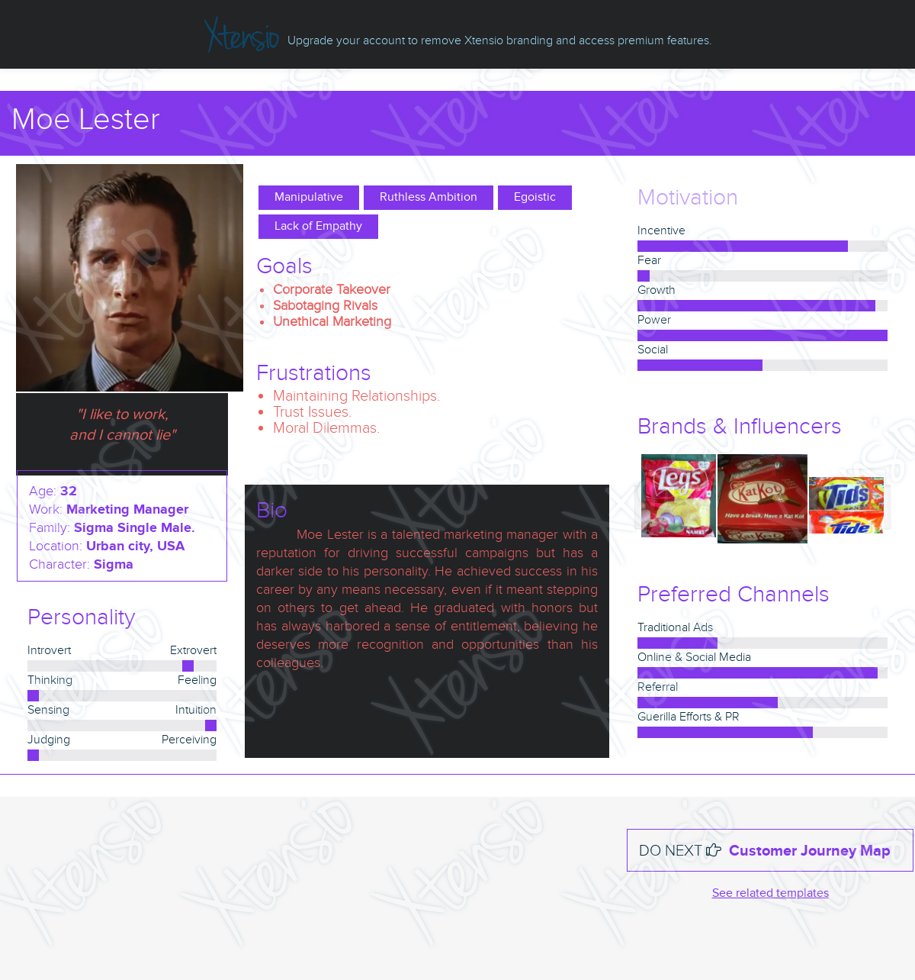

## **Problem Object Model:**

A problem object model would include entities like "User," "Medication," "Order," "Prescription," "Inventory," "Doctor," and "Pharmacist," with appropriate relationships and attributes to represent their interactions and properties.

However, creating a complete problem object model or entity-relationship diagram requires a deeper understanding of the specific system's requirements, constraints, and functionalities. Feel free to ask for more details or specific components for the object model or diagram

## 

## **ER Diagram**

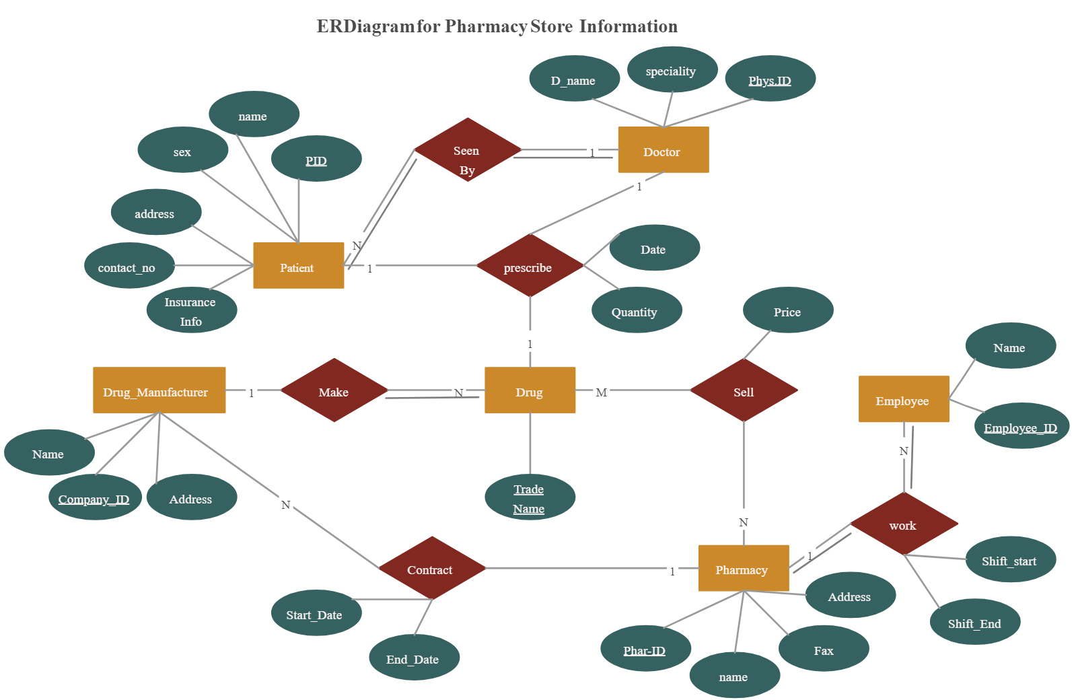

**Results and Discussions :**

Understanding the key users, tasks, and domains of the Online Pharmacy and Drugs Store platform is essential for its success. Patients, doctors, and pharmacists are the main users, each with specific needs. Patients need an intuitive interface for easy medication ordering, doctors need a secure and efficient prescription verification system, and pharmacists require a streamlined medication dispensing process. The core domains involve pharmaceuticals, user profiles, orders, and inventory, necessitating accurate and up-to-date information, strong data privacy, and efficient order tracking. Creating a persona like "Sarah Thompson," a chronic pain patient, helps tailor the platform to meet users' specific goals and challenges. Additionally, developing a problem object model aids in visualizing the system's structure and guiding iterative development for a robust and adaptable platform.

**\*\*\*\*\***